

**S.K.Patel Institute Of Management and Computer Studies – MCA**

**A Constituent Collage Of Kadi Sarva Vishwavidhyalaya, Gandhinagar**

**Event Under MMPSRC-KSV : Oddo Hackathon – 2025**



**Team Name: Tech Titans**

|  |  |  |
| --- | --- | --- |
| **Sr no.** | **Name** | **Role** |
| 1 | Somani Parv S. | Project Leader |
| 2 | Korat Vyom R. | Project Developer |
| 3 | Ladola Priya D. | Business Analyst |
| 4 | Dave Vaidehi P. | UI/UX Designer |

1. **Problem Statement**

* **Chosen Problem:**

The agricultural supply chain faces inefficiencies that hurt both farmers and buyers. Middlemen take a significant share of farmers' earnings, leaving them with just 40-50% of their product’s value. Buyers struggle to verify product authenticity, freshness, and quality. The lack of direct farmer-to-buyer trade leads to financial instability for farmers and uninformed purchasing decisions for buyers.

* **Problem Analysis:**
* **Middlemen Exploitation:** Farmers rely on intermediaries due to limited direct market access, lack of pricing insights, and inefficient logistics. These middlemen control distribution channels, dictating low prices and reducing farmers' profit margins, leading to financial struggles, particularly for small-scale farmers.
* **Lack of Transparency:** Buyers have no standardized way to verify the quality and authenticity of farm produce, making direct purchases risky. Many hesitate to engage in direct transactions due to concerns about fraudulent sellers and inconsistent product quality. This lack of trust slows down trade and increases dependency on intermediaries.
* **Unfair Pricing & Market Instability:** Farmers lack access to real-time market data, making it difficult to decide when and at what price to sell their produce. Without a direct link to buyers, they often have no choice but to accept the prices set by middlemen or risk their produce going to waste. Market fluctuations further contribute to their financial insecurity.
* **Inefficient Logistics & Delivery:** Poor shipment tracking, delays, and inconsistent transportation infrastructure lead to product spoilage and financial losses for both farmers and buyers. The absence of an organized logistics system discourages direct transactions, reinforcing dependence on intermediaries and increasing costs.

These inefficiencies create an unfair agricultural market where farmers receive minimal returns for their hard work, and buyers face high costs and uncertainty in product quality. Addressing these challenges is essential to creating a transparent, efficient, and equitable agricultural trade system.

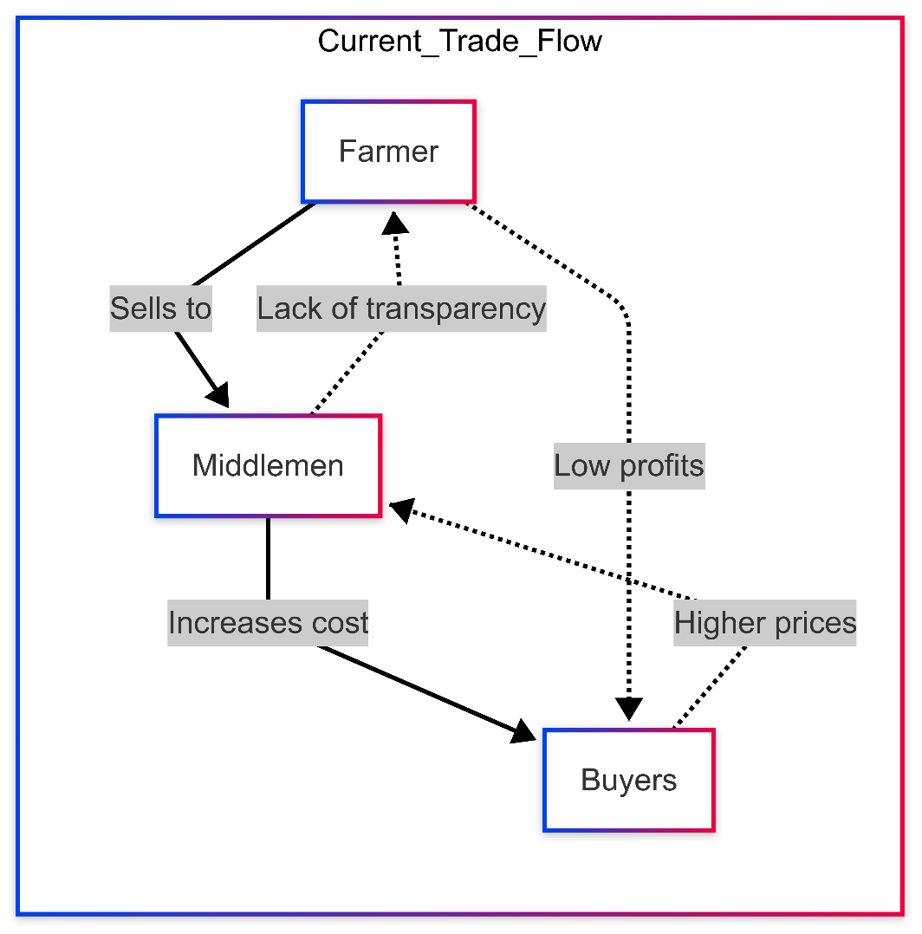

**Figure 1.1 Current Trade Flow**

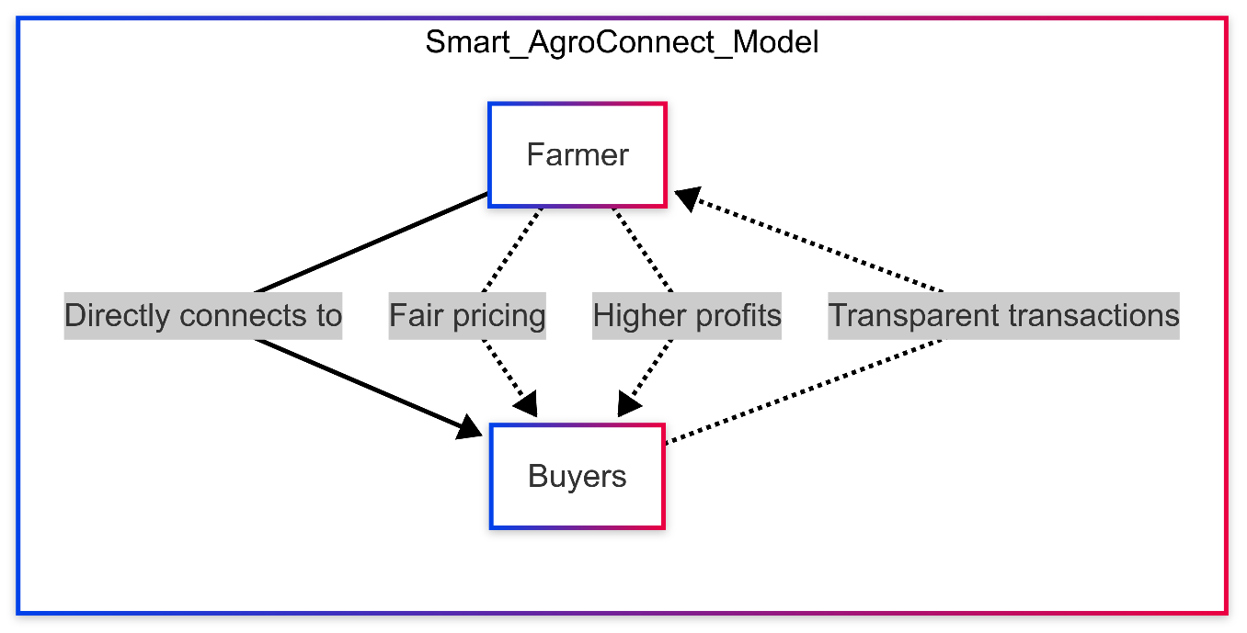

**Figure 1.2 Smart AgroConnect Flow**

* **Target Audience:**
* **Primary Beneficiaries:**

1. **Farmers –** Both small-scale and commercial farmers seeking better market access, fair pricing, and direct trade opportunities without middlemen. The platform empowers them with price transparency and higher profit margins.
2. **Buyers –** Retailers, wholesalers, supermarkets, and direct consumers looking for authentic, fresh, and verified farm produce. They gain access to quality products with transparent pricing and direct sourcing options.
3. **Agricultural Cooperatives –** Organizations that assist farmers in improving their market presence, optimizing sales strategies, and ensuring sustainable agricultural trade practices.

* **Secondary Beneficiaries:**

1. **Government Agencies & Policymakers –** Can utilize the platform to drive agricultural reforms, promote fair trade, and support rural economic growth by enabling direct farmer-to-consumer connections.
2. **Logistics & Supply Chain Providers –** Benefit from an integrated tracking and transportation system that enhances efficiency, reduces delays, and streamlines agricultural supply chains.
3. **Fintech Companies & Payment Services –** Gain opportunities to expand digital financial solutions, offering secure transactions, instant payments, and credit facilities for farmers and buyers.

By addressing the needs of both primary and secondary beneficiaries, Smart AgroConnect fosters a transparent, efficient, and equitable agricultural trade ecosystem.

1. **Solution Overview**

Smart AgroConnect is an innovative digital platform transforming the agricultural supply chain by directly connecting farmers and buyers, eliminating middlemen. This ensures fair pricing, secure transactions, and efficient logistics using AI, blockchain, and real-time tracking. The platform enhances transparency, trust, and economic empowerment for both farmers and consumers.

* **Key Features:**
* **AI-Powered Price Optimization –** Machine learning analyzes market trends, weather patterns, and supply-demand data to recommend optimal prices. This ensures farmers receive competitive rates while buyers avoid overpaying.
* **Secure Payments –** Transactions are safeguarded using Ethereum-based smart contracts, ensuring funds are securely held until buyers confirm the receipt of goods, preventing financial losses.
* **Direct Farmer-to-Buyer Connection –** Farmers can list their produce, and buyers can place orders directly, removing costly intermediaries. This enhances profitability for farmers and ensures buyers access high-quality products at fair prices.
* **Real-Time Logistics Tracking –** Integrated GPS tracking provides live shipment updates, ensuring smooth, transparent deliveries. Buyers stay informed about their orders, reducing uncertainty in agricultural trade.
* **Verified Transactions –** A robust verification process ensures only genuine farmers and buyers are registered, eliminating fraud and creating a trustworthy trading environment.
* **Live Bidding System –** Buyers can place competitive bids on agricultural produce, while farmers set a minimum price to ensure they never sell below cost. This dynamic pricing model fosters fair competition, transparency, and better financial outcomes for farmers.

By leveraging cutting-edge technology, Smart AgroConnect streamlines agricultural trade, ensuring efficiency, fairness, and security for all stakeholders.

* **Uniqueness:**

Smart AgroConnect stands apart from other agricultural marketplaces due to its **unique combination of AI, live beading, and transparent trade models**:

* **AI-Driven Price Optimization:** Unlike traditional marketplaces where farmers rely on fluctuating market prices, Smart AgroConnect provides **real-time pricing insights**, empowering farmers to make informed decisions.
* **Live Beading System:** Farmers can benefit from a competitive pricing model, ensuring they receive the best possible price for their produce through an open, transparent beading process.
* **Secure Payment System:** Unlike existing platforms that lack transaction transparency, Smart AgroConnect guarantees secure, verified payments through a protected and fraud-proof system.
* **End-to-End Logistics Tracking:** Farmers and buyers can **track shipments in real-time**, eliminating delays and uncertainty in product deliveries.
* **Direct Trade Model:** By **removing middlemen**, the platform ensures farmers receive **fair compensation** and buyers get **fresh, high-quality farm produce** at **reduced costs**.
* **Multi-Stakeholder Accessibility:** The platform supports **small and large-scale farmers, buyers, cooperatives, and policymakers**, making it a **scalable, industry-wide solution**.

By integrating **fair trade practices, advanced technology, and farmer empowerment**, Smart AgroConnect offers an **innovative, future-ready approach** to agricultural commerce, ensuring economic prosperity for both farmers and buyers.

1. **Frameworks & Technologies**

* **Tech Stack:**

Smart AgroConnect is built on a modern and scalable technology stack to ensure efficiency, security, and a seamless user experience. The chosen frameworks, libraries, and technologies include:

* **Frontend:** React.js with Material-UI for an interactive and responsive user interface.
* **Backend:** Node.js with Express.js for a fast, scalable, and lightweight server-side application.
* **Database:** PostgreSQL for structured data storage and MongoDB for unstructured data and analytics.
* **Authentication & Security:** Firebase Authentication and JWT (JSON Web Tokens) for secure user authentication.
* **Payments:** Stripe and Razorpay for secure and seamless payment transactions.
* **Machine Learning:** TensorFlow and scikit-learn for AI-powered price optimization.
* **Real-Time Tracking:** Google Maps API and GPS integration for logistics tracking.
* **Cloud & Hosting:** AWS (Amazon Web Services) for scalable cloud infrastructure and storage.
* **Live Beading System:** WebSocket with Socket.io to enable real-time communication between farmers and buyers.
* **Reasoning:**

The selected technologies are chosen based on scalability, ease of use, and cost-effectiveness:

* **Scalability:** Node.js and PostgreSQL ensure that the platform can handle high traffic and large volumes of transactions efficiently.
* **Ease of Use:** React.js and Material-UI offer a user-friendly and visually appealing interface, improving accessibility for farmers and buyers.
* **Security:** Firebase Authentication, JWT, and secure payment gateways provide robust security, preventing fraud and unauthorized access.
* **Cost-Effectiveness:** Open-source frameworks like TensorFlow, Express.js, and Socket.io help reduce development costs while maintaining high performance.
* **Assumptions & Constraints:**

While developing Smart AgroConnect, several assumptions and constraints need to be considered:

1. **Internet Accessibility:** The platform assumes that farmers have access to a stable internet connection, which may not always be the case in remote areas.
2. **User Adoption:** Farmers may require training or onboarding support to fully utilize the platform’s features.
3. **Regulatory Compliance:** The platform must adhere to agricultural trade regulations and payment processing laws in different regions.
4. **Scalability Challenges:** As the user base grows, infrastructure upgrades may be required to maintain performance and reliability.
5. **Data Accuracy:** AI-based price optimization depends on the accuracy of market and weather data, requiring reliable data sources.
6. **Payment Processing Limitations:** Some farmers may not have access to digital banking, which could slow adoption rates for secure online transactions.

By addressing these challenges and optimizing the tech stack, Smart AgroConnect aims to provide a robust and future-proof solution for the agricultural supply chain.

1. **Feasibility and Implementation**

* **Implementation Ease:**

Developing and deploying **Smart AgroConnect** is highly feasible due to the use of modern, widely supported technologies and a scalable cloud-based infrastructure. The implementation follows a phased approach to ensure smooth development, testing, and deployment:

* **Phase 1 - MVP Development:**
* Core functionalities such as farmer registration, product listing, and buyer ordering will be built using **React.js** for the frontend and **Node.js with Express.js** for the backend.
* **Firebase Authentication and JWT** will ensure secure user authentication.
* A structured database using **PostgreSQL** will be set up for transactional data, while **MongoDB** will handle analytics.
* **Phase 2 - AI Integration & Live Bidding:**
* Machine learning models, developed using **TensorFlow and scikit-learn**, will provide AI-powered price optimization based on market trends and demand.
* **Socket.io** will enable real-time live bidding, allowing buyers to compete for produce in a transparent marketplace.
* **Phase 3 - Logistics & Payment Systems:**
* **Google Maps API** and **GPS tracking** will be integrated for real-time shipment monitoring, ensuring seamless logistics.
* Secure financial transactions will be facilitated using payment gateways like **Stripe and Razor pay**.
* **Phase 4 - Testing & Deployment:**
* Comprehensive testing for usability, security, and performance will be conducted to ensure reliability.
* Deployment on **AWS cloud servers** will provide scalability and global accessibility.
* A feedback-driven approach will be implemented for continuous monitoring, feature enhancements, and system improvements.

By leveraging **cloud services, containerized deployment (Docker), and scalable databases**, Smart AgroConnect can efficiently handle a growing user base, high transaction volumes, and evolving business needs.

* **Effectiveness:**

Smart AgroConnect effectively addresses key challenges in the agricultural supply chain by providing a **transparent, secure, and efficient** trade platform.

* **Direct Farmer-to-Buyer Connection:** Eliminates middlemen, ensuring farmers get **fair compensation** and buyers receive **fresh, high-quality produce** at competitive prices.
* **AI-Powered Price Optimization:** Ensures farmers receive optimal prices for their produce based on **real-time market trends, demand, and weather conditions**.
* **Live Beading System:** Introduces **dynamic pricing** where buyers compete for farm produce, maximizing farmer earnings.
* **Secure Transactions:** **Fraud-proof payments** ensure financial security for both farmers and buyers, increasing trust in digital transactions.
* **Real-Time Logistics Tracking:** Reduces uncertainties in shipment delays by **providing live tracking updates** to buyers and farmers.
* **Scalability & Accessibility:** The platform supports **small-scale and large-scale** farmers, cooperatives, and policymakers, making it a **future-ready and inclusive** solution.

By integrating advanced technologies and a user-friendly interface, Smart AgroConnect **enhances economic opportunities for farmers, improves supply chain efficiency, and f**

1. **UI/UX Mock-up**

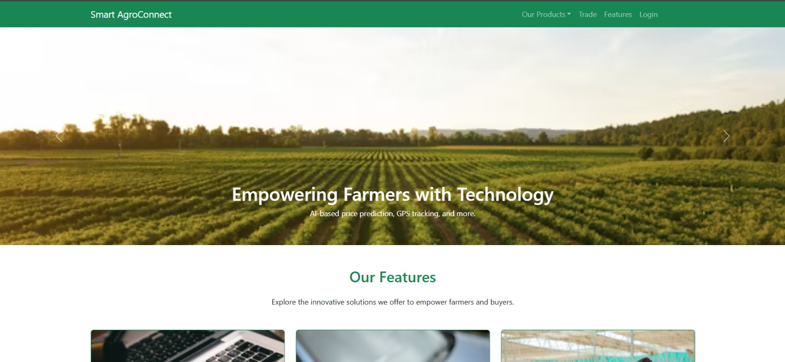

**Figure 1.3 Homepage**



**Figure 1.4 Our Feature**

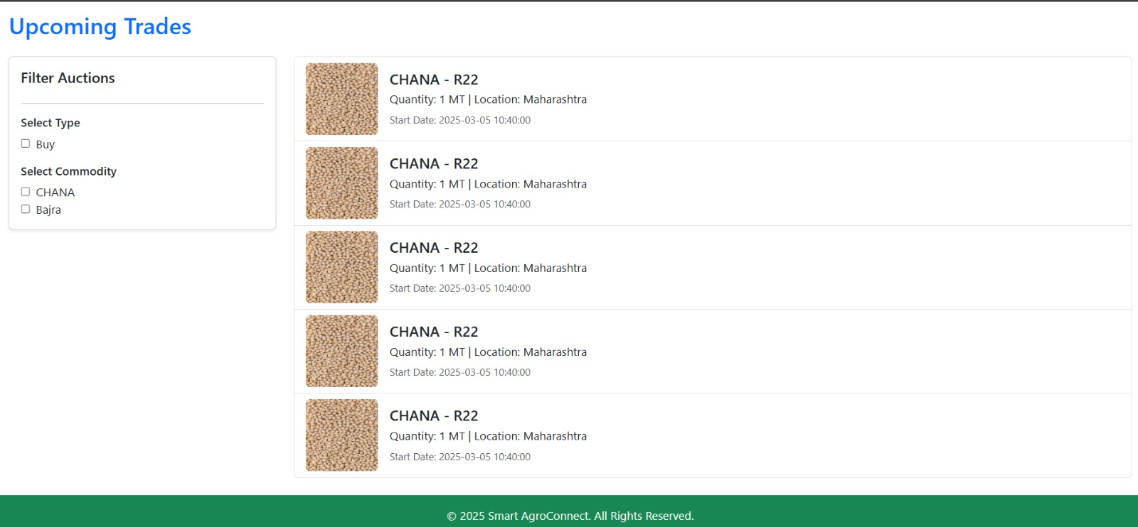

**Figure 1.5 Beading**

1. **Business Scope and Use Case**
2. **Small-Scale Farmer Selling Directly to Buyers**
   * Rajesh, a small-scale vegetable farmer, traditionally sells his produce to local middlemen who offer him low prices.
   * With **Smart AgroConnect**, Rajesh lists his fresh tomatoes on the platform, where multiple buyers place bids in a **live auction**.
   * He sells at a **higher price than the market rate**, ensuring better profit margins without middlemen deductions.
3. **Bulk Buyer Securing High-Quality Produce**
   * Green Fresh Supermarket needs a consistent supply of organic fruits.
   * Through Smart AgroConnect, they browse verified organic farmers, compare prices, and **place bulk orders directly**.
   * The platform’s **real-time logistics tracking** ensures timely delivery, reducing supply chain uncertainty.
4. **Price Optimization for Seasonal Produce**
   * A mango farmer, Suresh, faces fluctuating prices every season.
   * The **AI-powered price optimization** in Smart AgroConnect provides him with **real-time price insights** based on demand, weather, and competitor rates.
   * He **times his sales strategically** to maximize profits, preventing losses from sudden market crashes.
5. **Empowering Women Farmers**
   * Many women-led farming cooperatives struggle with reaching larger markets.
   * Smart AgroConnect’s **direct-trade model** enables them to sell **nationwide**, eliminating exploitation by intermediaries.

* **Market Need:**
* **Growing Farm-to-Consumer Demand:** Consumers prefer fresh, local, and fairly priced produce.
* **Price Instability:** Farmers struggle with fluctuating prices controlled by middlemen.
* **Trust Issues:** Delayed payments and fraud impact farmers in traditional markets.
* **Agriculture Digitization:** Tech-driven solutions are gaining government and industry support.
* **Supply Chain Inefficiencies:** Buyers face logistics delays and inconsistent quality.

**Smart AgroConnect** solves these issues with fair pricing, transparency, and direct farmer-to-buyer trade.

**Revenue Model:**

1. **Transaction Fees:** A 2-5% commission on successful sales.
2. **Subscription Plans:** Premium features like analytics, priority listings, and logistics support.
3. **Logistics Fees:** Buyers can opt for Smart AgroConnect’s delivery services.
4. **Advertisements & Sponsored Listings:** Paid promotions for farmers and suppliers.
5. **Data Monetization:** Selling aggregated market insights to policymakers and agribusinesses.

With strong demand and diverse revenue streams, Smart AgroConnect is positioned as a scalable and sustainable agritech solution.

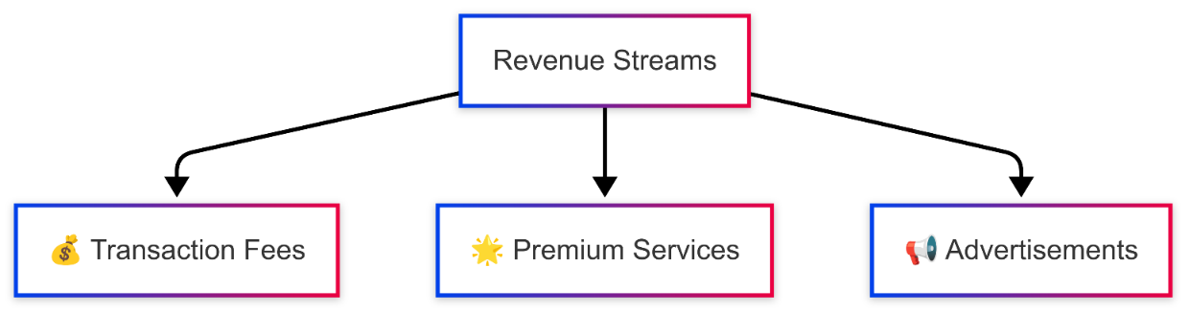

**Figure 1.6**

1. **System Design and Architecture**

* **Technologies Overview**

Smart AgroConnect is built using a **scalable, secure, and efficient** tech stack to ensure seamless operations. The key technologies used are:

* **Frontend:** React.js for an interactive user experience.
* **Backend:** Node.js with Express.js for high-performance API handling.
* **Database:** MongoDB for storing product listings, transactions, and user data.
* **AI & ML:** Python-based AI models for price prediction.
* **Payment Gateway:** Razorpay/Stripe for secure payment processing.
* **Real-Time Tracking:** Google Maps API for logistics and delivery tracking.
* **Authentication & Security:** JWT-based authentication with role-based access control.
* **Design Patterns**
* **Model-View-Controller (MVC):** Separates concerns between data, UI, and business logic.
* **Microservices Architecture:** Modular design for scalability and easy updates.
* **Observer Pattern:** Enables live beading notifications and real-time updates.
* **Functional Flow**

The platform follows a structured process to facilitate seamless interactions between farmers and buyers. The **workflow** is as follows:

1. **User Registration & Verification:**
   * Users sign up as **Farmers, Buyers, or Bulk Buyers**.
   * They **upload documents** for verification.
   * Admin **verifies and assigns a certified badge** to approved users.
2. **Product Listing & AI-Powered Pricing:**
   * Farmers list their **agricultural products**.
   * AI **analyses market trends** and suggests an **optimal price**.
   * Farmers can **accept or adjust** the AI-predicted price.
   * The product is listed in the **marketplace**.
3. **Buyer Search & Purchase Process:**
   * Buyers **search for products** using filters (**certified sellers, price, location**).
   * They **add items to cart** and **proceed to checkout**.
   * Payment is processed through **UPI/Razorpay** or held in a **secure escrow system**.
4. **Order Fulfilment & Logistics:**
   * Farmers **prepare orders** and assign a **logistics partner**.
   * **Real-time GPS tracking** is enabled for delivery monitoring.
   * Buyers receive **live updates** until the order is delivered.
5. **Transaction Completion & Farmer Payment:**
   * Buyers **confirm delivery**, after which **funds are released** to the farmer.
   * In case of disputes, **admin resolves issues** before fund release.
6. **Government Subsidy Application (For Farmers):**
   * Farmers can apply for **government subsidies** through the platform.
   * The system **fetches data from government APIs** to check eligibility.
   * Approved farmers receive **subsidy funds** directly in their accounts.
7. **Post-Transaction Actions & Monitoring:**
   * Buyers leave **reviews**, and farmer ratings are **updated**.
   * Admin **monitors platform activity** for any suspicious behaviour.
   * If fraudulent activity is detected, the account is flagged for **review and action.**

* **Flowchart:**

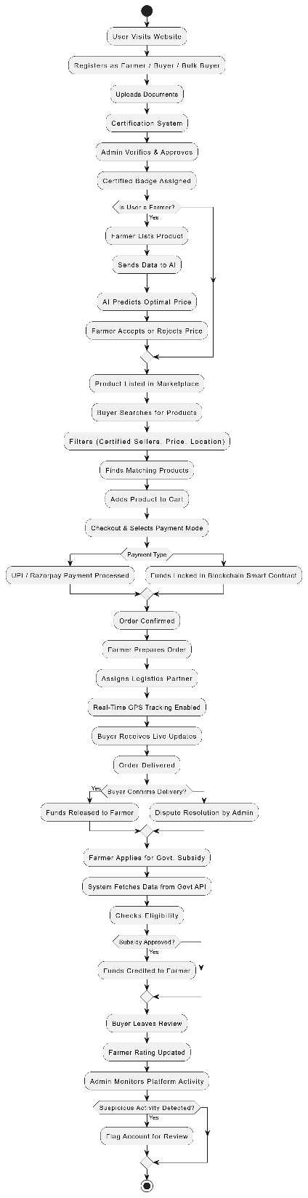

**Figure 1.7 Flowchart**

1. **Coding Approach**

* **Development Strategy**

The development of **Smart AgroConnect** follows an **Agile methodology**, ensuring flexibility, continuous improvement, and rapid adaptation to changing requirements. The approach includes:

1. **Sprint-Based Development:**
   * The project is divided into **small, manageable sprints**, each focusing on a specific module (e.g., user authentication, product listings, payment integration).
   * Regular **scrum meetings** ensure team alignment and progress tracking.
2. **Modular & Scalable Architecture:**
   * The platform follows a **modular design**, making it easy to scale and maintain.
   * **Microservices architecture** is used for backend operations, allowing independent service scaling.
3. **Version Control & Collaboration:**
   * Code is managed using **Git (GitHub/GitLab)** with a structured **branching strategy** (feature branches, develop, main).
   * Developers follow a **pull request (PR) workflow**, ensuring each change is reviewed before merging.
4. **Continuous Integration & Deployment (CI/CD):**
   * Automated **CI/CD pipelines** ensure fast and error-free deployments.
   * Tools like **GitHub Actions/Jenkins** automate testing and deployment.

* **Coding Standards**

To maintain high-quality, maintainable, and error-free code, the following best practices are followed:

1. **Code Review Process:**
   * Every code change goes through **peer reviews** before merging to the main branch.
   * Reviews focus on **code quality, security, and efficiency**.
2. **Clean Code & Best Practices:**
   * **Consistent naming conventions** for variables, functions, and classes.
   * **DRY (Don't Repeat Yourself) principle** to avoid redundant code.
   * **Proper documentation and inline comments** for better readability.
3. **Automated Testing:**
   * **Unit Testing:** Using **Jest** for frontend and **Mocha/Chai** for backend testing.
   * **Integration Testing:** Ensuring API endpoints work as expected.
   * **End-to-End Testing:** Simulating real user interactions using **Cypress** or **Selenium**.
4. **Security & Performance Optimization:**
   * Implement **input validation & sanitization** to prevent SQL injection and XSS attacks.
   * Optimize **database queries** and use caching (Redis) to improve performance.
   * Use **secure authentication mechanisms** like JWT-based tokens and OAuth.
5. **Additional Supporting Documents**

* **Market Research**

The **Smart AgroConnect** platform is built on extensive market research that highlights the growing demand for **direct farmer-to-consumer marketplaces**. Key insights include:

* **Rising Demand for Organic & Locally Sourced Produce:** Consumers prefer fresh, organic, and locally sourced products, leading to an increased need for **efficient farm-to-home platforms**.
* **Challenges in Traditional Supply Chains:** Studies indicate that **40% of agricultural produce is lost** due to inefficient distribution channels and middlemen. Our platform **streamlines transactions** and **reduces waste**.
* **Digital Transformation in Agriculture:** Research from **Statista** suggests that the global **AgriTech market** is expected to grow by **10.2% CAGR by 2027**, emphasizing the need for digital solutions.
* **Key Differentiators of Smart AgroConnect:**
* **AI-Based Pricing**: Our platform uniquely integrates **AI-powered price prediction**, unlike competitors that rely on traditional pricing.
* **Blockchain for Transparency**: Unlike AgriBazzar and Ninjacart, our solution **secures transactions via blockchain**, ensuring trust between buyers and farmers.
* **Logistics Integration**: We provide **real-time GPS tracking** for orders, enhancing supply chain visibility.
* **Certified Buyer & Seller System**: We ensure **verified participants**, increasing platform credibility.
* **Competitor Analysis**

A comparison of **Smart AgroConnect** with existing AgriTech solutions:

| **Feature** | **Ninjacart (India)** | **AgriBazzar (India)** | **Ripe.io (USA)** | **Smart AgroConnect (Our Solution)** |
| --- | --- | --- | --- | --- |
| **Core Focus** | B2B Agri-Supply Chain | Digital Marketplace | Blockchain for Food Transparency | AI-Driven Direct Farmer-to-Buyer Marketplace |
| **AI-Based Price Prediction** | ❌ | ❌ | ❌ | ✅ |
| **Blockchain for Transactions** | ❌ | ❌ | ✅ | ✅ |
| **Direct Farmer-to-Buyer Sales** | ❌ | ✅ | ❌ | ✅ |
| **Logistics & GPS Tracking** | ✅ | ❌ | ❌ | ✅ |
| **Certified Farmer & Buyer System** | ❌ | ✅ | ❌ | ✅ |

✅ = Available | ❌ = Not Available

* **References**
* Statista Reports on AgriTech Growth: [www.statista.com](https://www.statista.com/)
* NASSCOM AgriTech Report 2023 – [www.nasscom.in](https://www.nasscom.in/)
* World Bank: Agricultural Digitalization & Farmer Welfare – [www.worldbank.org](https://www.worldbank.org/)
* Government of India, Ministry of Agriculture Data – [www.agricoop.nic.in](https://www.agricoop.nic.in/)